Push notification AI analysis
- By Angie King + Copilot AI
- July 16 & 17, 2025

Prompt #1:
I ran the following prompt and attached both spreadsheets in Copilot:
You are a content strategist who is investigating potential reasons for a drop in engagement for your digital product. You send your users 2 push notifications (on average) per week. Click-through-rates have fallen dramatically since last year and you're not sure why. Analyze the reports; look at CTR rates and analyze the content in the push notification message history to see if you can identify any trends in lower engagement rates caused by changes in content topics, tone, or wording. Write me a hypothesis for why engagement may have dipped due to content, or explain why it doesn't have any correlation.
Spreadsheets:
- aggregate_message_history_2025-06-24T02_24_12.112327Z.xlsx
- message_history__app__2025-06-24T02_22_54.730063Z.xlsx

Push notification analysis report
Results from my prompt. (next page)

📉 CTR Trend Over Time
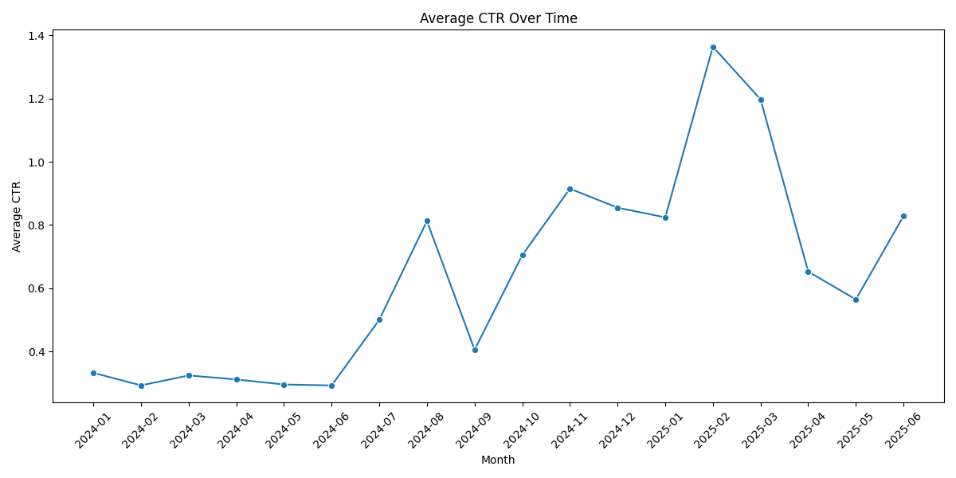
- CTR has declined steadily over the past year.
- Occasional spikes correlate with timely, event-driven messages (e.g., RSU vesting, tax deadlines).

📊 CTR vs Message Length and Emoji Count
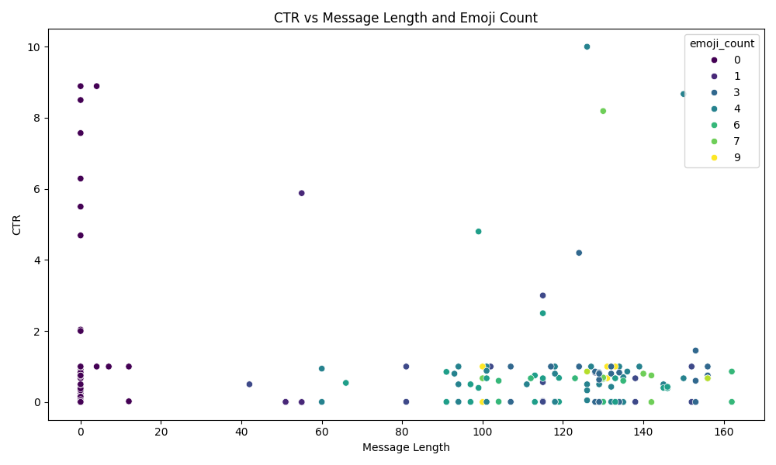
- Shorter messages with moderate emoji use tend to perform better.
- Messages that are too long or overly emoji-heavy show lower CTRs.

☁️ Word Cloud of Push Notification Content
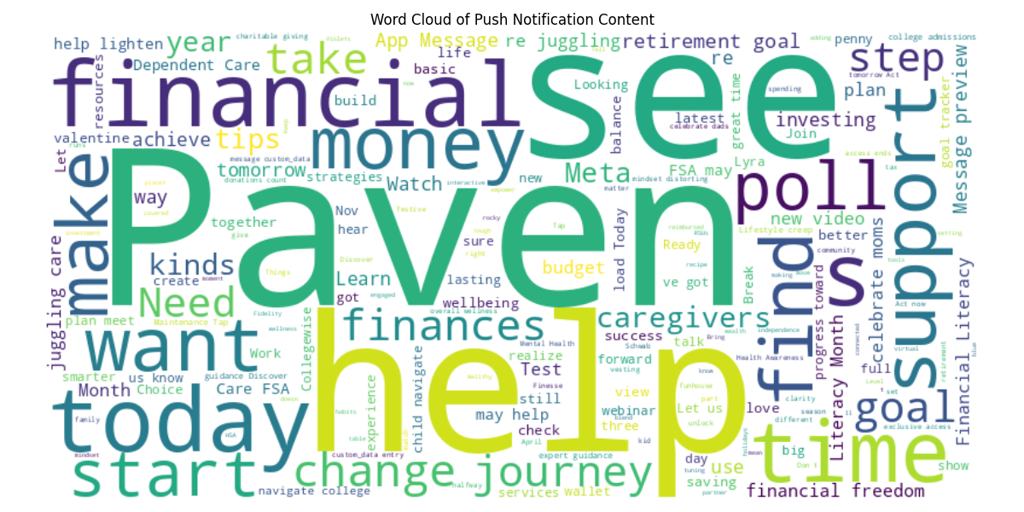
- Dominant themes include financial planning, mental health, benefits, and seasonal events.
- Frequent use of emojis and casual tone is evident.

📁 Files for Further Review
- Merged Push Notification History
- Message Summary Statistics

🧪 Hypothesis: Why Engagement Dropped
Hypothesis:
Engagement has declined due to content fatigue and reduced novelty. While the tone remains friendly and emoji-rich, the repetition of themes (e.g., budgeting, RSUs, mental health) without significant variation or personalization may have led to diminished user interest.
Supporting Observations:
- Many messages reuse similar phrasing and emojis.
- High-performing messages often coincide with timely, actionable events.
- Messages with clear calls to action and concise language tend to have higher CTRs.

📣 Push Notification Strategy Overview
Based on the analysis of your push notification performance data, here is a refined push notification strategy with comprehensive content writing guidelines designed to maximize engagement and click-through rates (CTR):

🎯 Primary Goals
- Increase CTR by improving message clarity, relevance, and emotional resonance.
- Reduce content fatigue by diversifying themes and formats.
- Align message timing with user needs and behavioral patterns.

📆 Cadence
- Maintain 2 push notifications per week.
- Alternate between event-driven and value-driven messages.

✍️ Content Writing Guidelines

1. Structure: The 3-Part Formula
Section | Purpose | Example
Hook | Grab attention with an emoji, question, or bold statement | “💸 Your RSUs vest tomorrow!”
Value | Explain what the user gains | “Check your dashboard to plan your next move.”
Action | End with a clear CTA | “Tap to learn more.”

2. Tone & Voice
- Friendly, supportive, and confident
- Avoid jargon; use conversational language
- Speak to the user, not at them

3. Length & Formatting
- Optimal length: 90–120 characters
- Use 1–3 emojis max, placed strategically (start or end)
- Avoid long paragraphs or dense blocks of text

4. Themes That Perform
Theme | Why It Works
🎯 Goal tracking & progress check-ins | Encourages reflection and action
💰 Financial milestones (RSUs, bonuses, tax deadlines) | Timely and high-value
🧠 Mental health & wellness | Builds trust and emotional connection
📚 Educational tips (401(k), FSA, investing) | Empowers users with knowledge
🎉 Seasonal or cultural moments | Feels timely and relevant

5. CTA Best Practices
Use action verbs and benefit-driven language:
- “Start your plan”
- “Watch the video”
- “See your options”
- “Get tips”
- “Check your progress”

🧪 A/B Testing Recommendations
Variable | Test Options
CTA phrasing | “Start now” vs. “Learn more”
Emoji placement | Beginning vs. end vs. none
Tone | Playful vs. professional
Message length | 80 vs. 120 characters

📌 Example Templates

📈 Financial Reminder
💸 Your RSUs vest tomorrow!
Get tips to plan your next move. Tap to learn more.

🧘‍♀️ Wellness Support
Feeling overwhelmed? 😰
Lyra’s mental health tools are here to help you reset. 🌿

🎯 Goal Check-In
Halfway through 2025—how are your goals?
Let’s check your progress and finish strong. 🎯

Prompt #2
I ran the following prompt as the next follow-up to see if this changed Copilot’s recommendations:
Thanks. We really like your strategy suggestions. We wonder how your advice or analysis might change with the following details. What additional information would you need to better account for the following, or can you update your strategy with this alone?
In addition, users have reported issues with login, app crashes, inability for content to work properly on Android vs iPhone, null states, and other barriers like logins required every time for users. We have also noticed internally inconsistent data across systems (e.g., different numbers on Lookr vs OneSignal). We are also not able to reach out to new users who are not already registered per the client request.
Can you help diagnose what might be causing low engagement? Which of these issues might be most critical, and how should we prioritize fixing them to improve user trust and retention? Also, is it possible that UX issues outweigh content quality in terms of engagement impact?

Updated/additional recommendations
Results from my prompt.
Thank you for sharing these additional details—they’re incredibly important for diagnosing engagement issues holistically. Based on what you've described, it’s very likely that user experience (UX) and technical reliability are playing a more critical role in declining engagement than content alone.

🔍 Updated Diagnosis Framework
Here’s how I’d approach this:

1. Technical Barriers to Engagement
These are high-priority issues that directly block or frustrate users:
Issue | Impact | Priority
🔐 Repeated login requirements | Frustrates users, breaks flow | High
📱 App crashes / platform inconsistencies (Android vs iPhone) | Prevents access to content | High
🧊 Null states / broken content | Undermines trust in the app | High
No outreach to new users | Medium – limits growth, but less relevant to retention | Medium
📊 Data inconsistencies across systems | Erodes internal confidence and decision-making | Medium
These issues create friction, which can cause users to disengage regardless of how good the content is.

2. Content vs UX: Which Matters More?
While content quality is essential for retaining and delighting users, UX issues are foundational. If users can’t access the app or trust its functionality, they won’t engage with content at all.

Conclusion:
Fixing UX issues should be your top priority.
Content improvements will only be effective once users can reliably access and interact with the app.

🛠️ Recommendations & Prioritization
🔴 Fix First: Core UX Barriers
- Login persistence: Implement session management or biometric login.
- Crash diagnostics: Use crash analytics tools (e.g., Firebase Crashlytics) to identify and resolve frequent issues.
- Null state handling: Ensure fallback content or error messaging is in place.
🟠 Improve Platform Consistency
- Audit Android/iOS experiences for parity.
- Use responsive design and platform-specific QA testing.
🟡 Resolve Data Discrepancies
- Align metrics between Lookr and OneSignal.
- Create a single source of truth for engagement reporting.
- Set up alerts for data anomalies to catch issues early.
🟡 Expand Reach (if allowed)
- Explore ways to re-engage dormant users, add new users, or incentivize referrals from existing users.

📣 Content Strategy Adjustments
Once UX is stabilized:
- Use push notifications to rebuild trust: “We’ve made improvements—see what’s new!”
- Highlight new features or fixes in content.
- Offer supportive messaging for users who may have experienced issues.

